Transcript – Griffith Library Online Resources Overview Video

While there are physical library spaces in each Griffith campus, the library also has a suite of online resources to support remote learning as you study and research off-campus.

In this video we're going to take a look at these online resources and encourage you to develop your use of these as you progress through your studies.

Griffith Library Website

The central online library presence is the library website

Here you can access some important resources and the latest information, such as library news and events, contact details, and opening hours.

The Library Catalogue

One of the most important resources for you is the library catalogue, where you can access books on your reading list, and supplementary reading.

Simply enter your search in the catalogue search box to view the text books we hold in the library. You can limit your search for eBooks through here also.

Academic Databases

Another very important resource is the online databases, which you'll be using for your academic research.
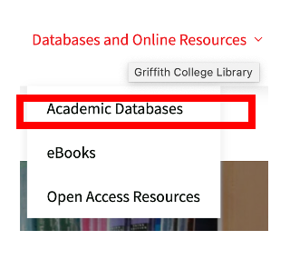
This should be your starting point for any of the research for your assignments.

These can be accessed remotely from anywhere.
You can sign in using your Single Sign-on details. (firstname.surname@student.griffith.ie / dd/mm/yyyy)

If you click on the relevant link you'll be directed through Moodle, and you simply sign-on with your usual details.

Recommended Online Resources – Open Access

To complement these academic online subscription databases, the Library also provides access and links to faculty recommended open access resources.

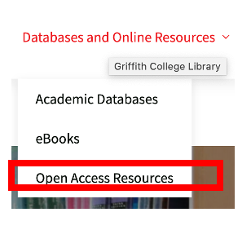

These are also quality, online resources that can further support you in your studies.

Academic Library Support

The library website also offers access to a range of supports to help you with your academic writing and research skills.

Referencing Guides

You can access the referencing style guides here.

In Griffith College we use our in-house style for Harvard referencing, which can accessed under this section of the library website.

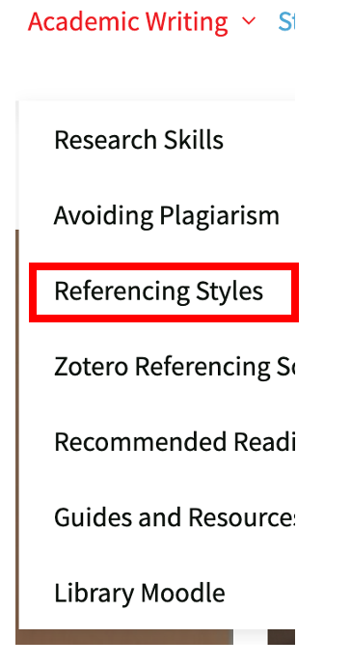

If you're a Law student, you can access the Oscola Ireland legal referencing style here also.

Academic Writing Supports

When it comes time to be working on your assignments you can find a number of guides and tutorials to support you, on the library website.

Library Moodle

To support these, the library pages on Moodlehttps://moodle.griffith.ie/course/view.php?id=11 offer you further short courses, tutorials and guides to help you in developing your academic skills.

Throughout the library website and Moodle, we will often direct you to tutorials on the Library YouTube channel. Here you can find our latest video uploads, and our recommended playlists.

Dissertations Online

We're proud of our student’s work here in Griffith College.

If you are a Masters student, you can visit our institutional repository, Griffith Online

Here you can view quality dissertations produced by previous Griffith College Masters students.

This suite of online resources are here to support our learners, working remotely and independently.

In person support – Talk to a librarian

However, we understand that nothing can replace in-person support, and face to face meeting.

And so, we offer a variety of ways in which you can access library staff for support.

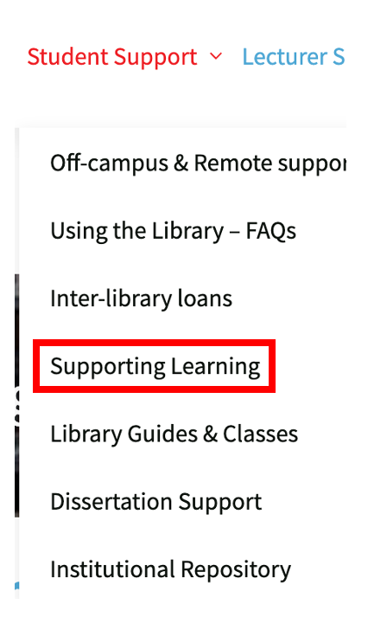

You can book one to one meetings, or smaller group labs which are available in-person and remotely through Zoom.

Or, we also encourage you to drop in to one of our regular Zoom - Ask a Librarian sessions.
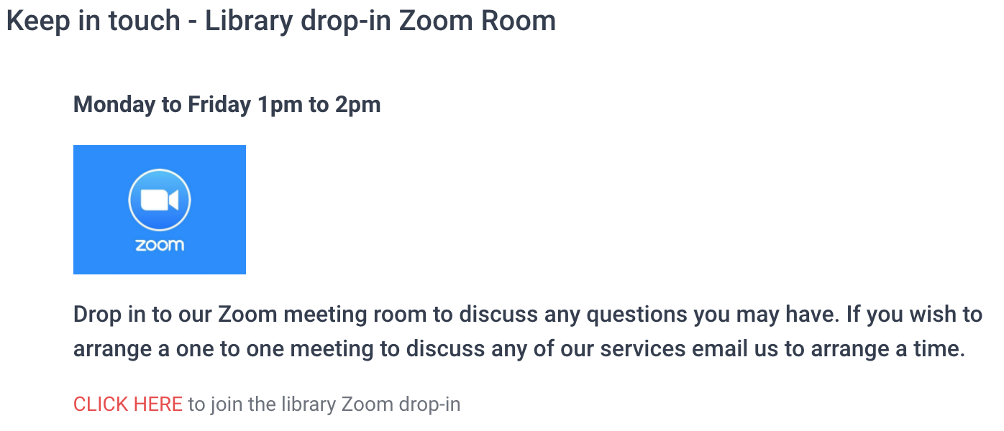

You can access the link to this through the library pages on Moodle.

Contact the Library

If you've got any queries or questions at all, please do contact us.

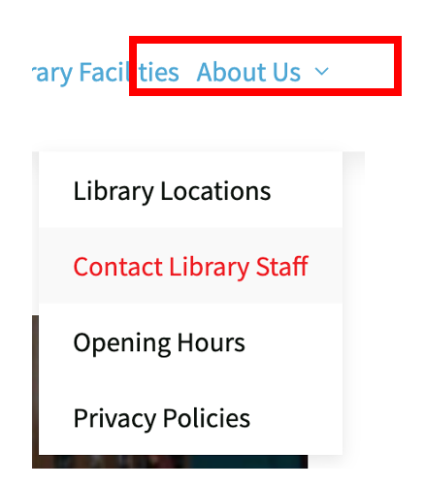

Or you can follow up for the latest news and updates on our library Twitter handle, @gclibrarian.

