Accessing eBooks through the Griffith College Library Catalogue

This guide is to demonstrate how you can access eBooks from the library catalogue when off-campus.
- You can access the library catalogue through the Library Website homepage.
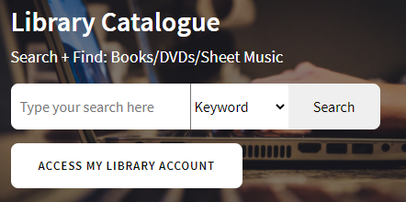
- You can also access the catalogue directly by typing in http://books.griffith.ie into the address bar at the top of your browser window. You do not need a password to browse the library catalogue at this point, as it is open access.
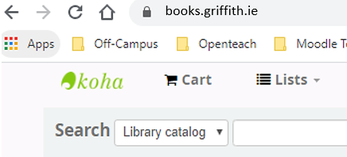
- Click on the Advanced Search link.
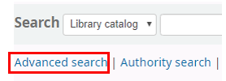
- Select the Electronic resource option to limit your search to viewing only eBooks and Resources available to read or access online.
- You can Refine this search further in several ways.
- Adding in a second Keyword term into the search field. For example add the term law or business into your research.
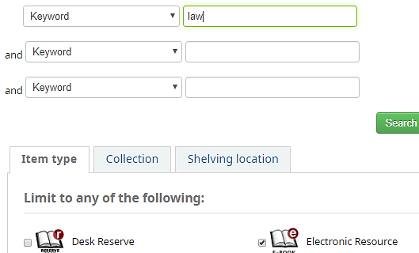
- Limit using the options to the left side of the screen.

For example: by title, authors, or by topic.
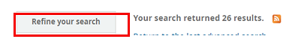
Top Tip: It can useful to keep your search reasonably wide at first, as this can allow you to discover texts that you are not familiar with.
- When you go into a book record you will need to select the Click here to access online link.
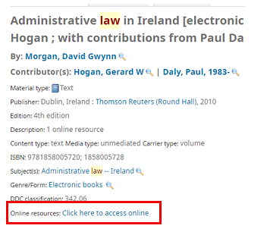
- If you are not logged into Moodle you will be prompted to do so at this point. Use your single sign on details (Your Moodle username and password)

